LENDA Setup Instructions

Hardware
Connect PMTs to HV power supply. Ensure you are using negative polarity.
Use a 50-ohm impedance matcher on a T-adapter to connect a BNC signal cable to the PMT.
You can connect the BNC directly to an oscilloscope to see the signal. Otherwise, use a BNC-to-LEMO adapter to connect BNC cable to a LEMO (silver) – to – SMB (gold) cable.
Plug in LEMO cable to Pixie-16 module.*** The convention we use is Top PMT in channel 0, Bottom PMT in channel 1; Top, Bottom for next bar, etc…
Slowly turn on HV and set to appropriate value. It’s important to manually ramp slowly at first to protect the PMTs.
- To start HV controller: /usr/opt/iseg/start.sh
- Check voltage ramp speed is 1%.
- Double-click number in V_{set} column and type desired voltage.
- Click status. Type “o” to turn on channel, “f” to turn off.
***We use Xia Digital Gamma Finder Pixie-16 modules to digitally process our pulses. Full documentation here: http://www.xia.com/Manuals/Pixie16UserManual.pdf. If you are inserting new modules into the crate, check to make sure the clock pins are set up correctly.
Clock Master: Slot 2 (leftmost) Clock Recipient: Slots 3-14 (contiguously to the right)
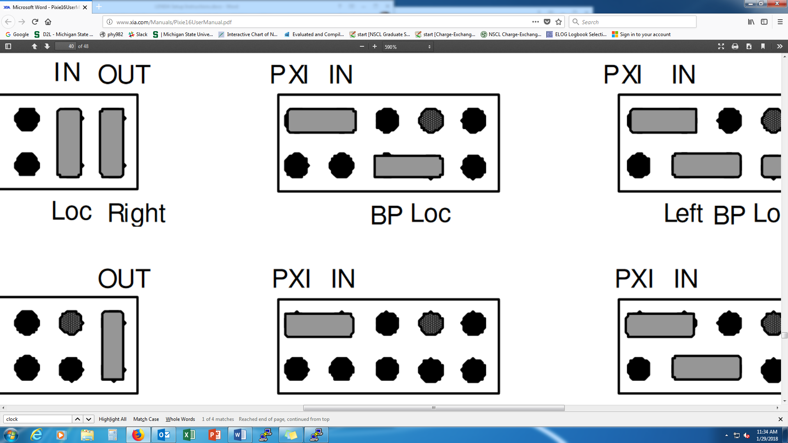

Software
Login to cedaq on the spdaq machine and open a terminal.
It is best to run the software from a remote machine, cedaq@daqcompute1. (Readout and SpecTcl will only run via daqcompute1). Use the terminal to access the daqcompute1 via the following:
ssh –Y cedaq@daqcompute1
the password is the same as the one used to login to the cedaq account on the spdaq machine.
Next, you must load the DDAS version and access the buster crate (virtual environment). This can be done via the following commands:
buster_load
nscldaq_load
Next, time to open up some of the software packages. There are 4 main programs that are used, each has their own function. Below is a brief explanation of what each is used for.
nscope: nscope is used to interface with the Digital Data Acquisition System (DDAS) by passing configuration parameters to the XIA Pixie-16 digitizers. These parameters include (and allow us to control) energy thresholds, coincidence requirements, detector baselines, gain settings, and many many more. It can also be used for visualization and checking the internal counting rates. Note: the file produced by nscope is used by Readout. If the file is not build correctly, Readout won’t run properly. ALSO: Readout and nscope CANNOT be open at the same time. They both use the event builder to generate events seen in the Pixie cards and will crash when used together.
Readout: Readout is used to collect and save data. As mentioned above, this uses the configuration file produced with nscope. One will be walked through with how to . In short, the data collected (and saved) with readout is saved temporarily to what is called a ring buffer. The data is then transferred off the ring to a different location. This is very simplified and most that use this guide won’t need to think about anything beyond this.
SpecTcl: SpecTcl is used for data visualization and online analysis. It can connect online and read data from the ring buffer or be used to analyze offline by loading the .evt files (although we typically use root for this purpose).
Scalers: Scalers is a program that reads rates in the pixie cards; it reads events read (in) and events processed (out). One would expect these numbers to be different due to many reasons, including but not limited to: events below energy threshold, events that don’t meet coincidence requirements, etc. This program requires readout to be running in order to measure rates (reminder that nscope does this as well but it won’t give rates during a run, only after).

Go to the “nsclddas” directory:
$ cd /nsclddas

nscope
Full documentation: http://docs.nscl.msu.edu/daq/newsite/ddas-1.0/nscope.html.
Check that the Pixie-16 configuration file is correct: “/nsclddas/crate_1/cfgPixie16.txt.” Make sure you have the correct number of modules and default settings file. Note that there should be no line breaks between lines.
1 # crate ID
2 # number of modules
2 # slot for module 0
3 # slot for module 1
/user/cedaq/nsclddas/crate_1/mySetFile.set # default set file

To run nscope, make sure you are in the “nsclddas” directory and type:
./gonscope
If you need to use a different settings file, open it first:
File Open mySetFile.set
Then start the program by clicking “Boot.” Wait for the blue “System Booted” message.
Adjust the settings if needed*** (See full documentation for details). Note that the “Mod CSRB” window will not show anything until you click “Load.”
To see a waveform: “Read WF”. Note this may take several seconds if for some reason nscope is not seeing any signals. If you click this multiple times, you’ll have to wait even longer.
You can also take un-recorded runs with nscope to check that you are seeing what you expect.
To start a run: “Expert Start Run”
To see histogram: “Read Histo”
To end a run: “End Run”
***nscope settings
Analog Signal Conditioning
DC Offset | Pixie-16 Digitizers apply a DC Offset to the analog signal. The “Adjust Offsets” button sets these automatically.
Gain | Pixie-16 Digitizers apply a gain to the analog signal. LENDA uses 0.9.
Sign | Pixie-16 Digitizers may need to invert the signal. Choose polarity of signal. LENDA is negative.
Energy Filter
TPeaking | “Length” in Pixie-16 manual Fig. 6.2. Sampling time before and after “Gap.” (See figure below.)
TGap | “Gap” in Pixie-16 manual Fig. 6.2. Roughly equal to rise time. (See figure below.)
Filter Range | Allows user to implement longer filters. See Pixie-16 manual Section 6.5. LENDA should have smaller value because of its fast pulses.
Trigger Filter
TPeaking | As short as possible. 4 ns is one clock tick, minimum TPeaking is 16 ns.
TGap | Zero.
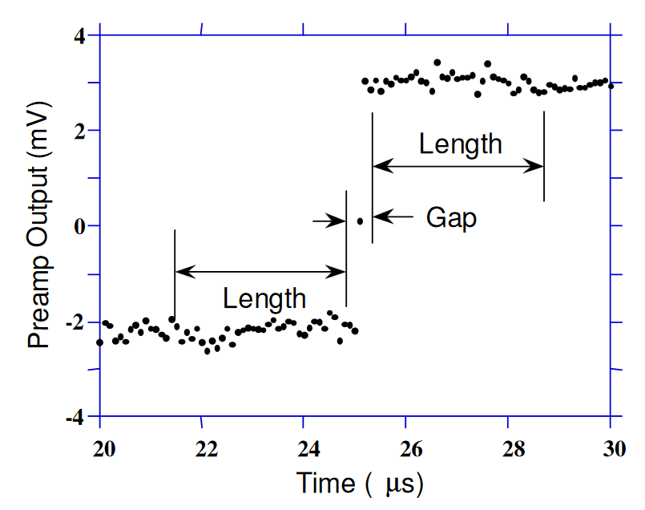
How to determine the threshold:
- Unplug everything from the module.
- Set the thresholds very low.
- Take a short run to see the count rate. You should see something ~10⁶ for all channels.
- Increase the thresholds to just above the point where all channels count zero.
- Then add 10 ADC units (14-bit card).
- This should yield a threshold of ~20 ADC units.

Scalers
Go to the “nsclddas/scalers” directory. Check that the ring buffer is correct in executable “goscalers”. To start the program, type:
$ ./gofullscalers

Readout
Full documentation: http://docs.nscl.msu.edu/daq/newsite/ddas-1.0/readout.html.
Go to the “nsclddas” directory. Check that correct spdaq machine is referenced in the file “ReadoutCallouts.tcl.” Check that the Pixie-16 configuration file is correct: “/nsclddas/crate_1/cfgPixie16.txt.” Make sure you have the correct number of modules and default settings file. Note that there should be no line breaks between lines.
1 # crate ID
2 # number of modules
2 # slot for module 0
3 # slot for module 1
/user/cedaq/nsclddas/crate_1/mySetFile.set # default set file

Check that the event-length file is correct: “nsclddas/crate_1/modevtlen.txt”
66 # Number of 32-bit words per event for module 0
66 # Number of 32-bit words per event for module 1

Example for how to calculate this number (from Jorge):
- The recorded trace length is 496 ns (set in nscope mySetFile.set via nscope – Pulse Shape Trace Length [us]).
- The Pixie module takes 1 sample every 4 ns (250 MHz Pixie).
- We get a total of 496/4 = 124 samples per recorded trace.
- Each sample is "recorded" as a 16-bit word. Thus, the total number of samples will take 124/2 = 62 (32-bit) words.
- Besides the trace, the Pixie module adds a "header" with four 32-bit words (carrying information about energy from the ADC, time from the CFD, event size, etc...).
- So we get 62 + 4 = 66 words. See Pixie-16 User’s Manual Chapter 4 for more details.
To run readout, make sure you are in the “nsclddas” directory and type:
$ ./goreadout
Check that the Data Source is Correct: Data Source List.
Example:
Source ID | Source Type | Parameter
0 | SSHPipe | host | spdaq04
 |  | parameters | --ring=cedaq --sourceid=1
 |  | path | /usr/opt/ddas/1.1-003/bin/Readout
 |  | wdir | /user/cedaq/nsclddas/crate_1

If the data source is not correct, you must first delete the old one, then add the new one so that the Source ID is 0.
Type the title of the run. Click “Start.” Wait for the following message in the “SSHPipe@spdaqXX” tab:
Scalers know crate ID = 1
Toggle whether or not you want to record the run. Toggle whether or not you want to time the run and set the appropriate time if you do.
To begin a run, click “Begin.”
Wait for data…
To end a run, click “End.”
Sometimes Readout crashes. If this is the case, you may need to manually kill all Readout processes. To see if there are any Readout processes running, type:
ps aux | grep Readout
If there are any Readout processes still running (besides the “grep” command), kill them with the following command, where XXXX is the process number (second column of output):
kill -9 XXXX

SpecTcl
Full documentation: http://docs.nscl.msu.edu/daq/spectcl/.
Go to directory “spectcl/LENDA-standalone-SpecTcl.” Check that the “MapFile.txt” matches the current setup. The columns in the Map File are Slot number (NOT module number!), Channel Number, Channel Name, Angle, Reference Channel Name. If you are using an external trigger, its name must start with “OBJ.” To run SpecTcl, type:
$ ./SpecTcl
To attach and detach online, first start a run in Readout. Then:
- In the “treegui” window: Data Source Online
  - Check the data source and make sure the Readout Destination ring matches what is given in Readout (usually “cedaqb”).
  - Make sure “ring11” is selected.
- In the “LENDA SpecTcl Control” window, click Attach Online.
Plots first need to be created in the “treegui” window. This can be done manually or by loading a plot definitions file.
- To create plots manually:
  - Choose a Parameter.
  - Set the Low, High, and number of Bins.
  - Type a spectrum name.
  - Click “Create/Replace.”
- To load a set of pre-defined plots:
  - Load definitions/myDefFile.tcl Open
Plots can be seen in the “Xamine” window. They can be selected manually, or you can open a windows file:
- To set up windows manually:
  - Spectra Display Spectrum
  - Select a spectrum from the list.
  - You can divide the window into multiple sections: Window Geometry, select number of rows and columns.
  - Note that if no plots are defined in the treegui window, then you will get an error.
- To open a windows file:
  - Window Read configuration
  - Select a *.win file.
  - Note that all of the plots defined in the *.win file must exist, or you will get an error.
Now you should see spectra filling up.

R00TLe
Git: https://git.nscl.msu.edu/
Full documentation: https://people.nscl.msu.edu/~pereira/R00TLe/annotated.html
Installation instructions are in the manual.
Use R00TLe on the fishtank machines. Analysis is not meant to be done on the spdaq machines.
Create an account if you do not have one:
$ R00TLeLogon.sh –f yourName
To login:
$ R00TLeLogon.sh yourName –a
Now you should be in directory “…/R00TLe/users/yourName/.”
To create a map file, go to the “prm/” directory. Create a new file called “MapFileXXXX.txt” where XXXX is the run number. If you are using an external trigger, its name must start with “OBJ.” If you do not create a map file for your run, it will use “MapFile.txt” as the default, and things will probably not work the way you want them to.
Convert .evt file to .root file:
Evt2Cal evtpath/myFile.evt rootpath/run-XXXX-00.root XXXX
where evtpath/ = /mnt/daqtesting/lenda/experiment/runXXXX/
and rootpath/ = ./rootfiles/
Modify files “src/Analoop.cc” and “src/Analoop.h” to create histograms of interest.
To run the analysis, open root and type:
[0] .x Run.C(XXXX)
This creates / overwrites the file “yourName/histograms/HistogramsFromRunXXXX.root,” which will contain all of the histograms you created in “Analoop.cc.”
To clone a new version of R00TLe if there have been updates in the repository:
- Move files you want to keep to a temporary folder outside of R00TLe (e.g. Analoops, MapFiles, macros, TimingAnalyzer).
- Remove R00TLe directory.
- git clone …
- go to R00TLe/src: $ make uninstall
- $ make install
- Check that the correct version of root is loaded in .bashrc (5.34.32)
- $ source ~/.bashrc
- $ echo $R00TLe_PRM (just to make sure everything installed properly)
- $ make clean
- $ make
- $ R00TLeLogon.sh –f yourName
- Move everything from the temporary folder back to its original place.

Troubleshooting
- Did you check the clock pins?
- Did you load Plx 9054 Kernel Module?
- Did you check the signal with a regular oscilloscope?
- Did you check the files “cfg_Pixie16.txt” and “modevtlen.txt” files?
- Did you adjust the offsets in nscope?
- Are you using the correct SPDAQ number?
- Are you using the correct Root version?
- Are you using the correct DDAS version?
  - .settings.tcl in stagearea
  - check the version number
  - use environment variables to verify version number
- Internet in the Lab:
  - If you can still open Firefox:
    - Go to Preferences.
    - Go to Advanced.
    - Go to Network.
    - Go to Settings.
    - Check the box "manual proxy."
    - Enter the proxy name (webproxy.nscl.msu.edu) and port number (3128).
    - Check the box "Use this proxy...."
    - That will fix it.
  - If you get the error “Firefox is already running…”
    - Open a terminal.
    - Enter “ps auxwww | grep firefox.”
    - If the process is there, kill it.
    - If the process is not there, continue to the next step.
    - Open the File Explorer.
    - Go to the directory “~/.mozilla/firefox/”
    - Go to each profile directory (some weird combination of letters and numbers).
    - Delete the files “lock” and “.parentlock” for all profiles.
    - That should fix it.

Timing Resolution Measurements
This section will outline how to set up a coincidence measurement between a LENDA bar and an external trigger, such as a liquid scintillator.

Top and Bottom Coincidences
We are always interested in events with a coincidence between the top and bottom PMTs of the LENDA bar. Put the top and bottom signals into channels 0 and 1 of the Pixie module, and connect the Pixie module to a breakout module (AA, BB). We want to enable pairwise coincidences between these two channels. First select “8x2” in the “Config Multi-Coincidence” window in nscope. This tells the module what type of coincidences to look for: coincidences between two adjacent channels. Then we must tell the module for which channels we want to enable the coincidence. We do this in the “CSRA” window. Check channels 0 and 1 only in the “CT” column.
It is beneficial to understand how the module defines coincidences. Channels 0 and 1 generate a “fast trigger” when they receive a signal. Then a “delayed fast trigger” signal is created, and this is a copy of the fast trigger delayed by the amount given by the “Fast Trigger Delay” in the “Timing Controls” window. (Note this is limited to 2 μs. If a larger number is given, you run out of bits and start over, e.g. 3 μs 1 μs.) Then the delayed fast trigger opens a validation window with a width given by “Fast Trigger Width” in the “Timing Controls” window. (The “OR” between these windows for all channels is given by o6.) The overlap of these two windows generates a third window, shown in the figure below. This is the coincidence gate, and it is given by “o7” in the breakout module.
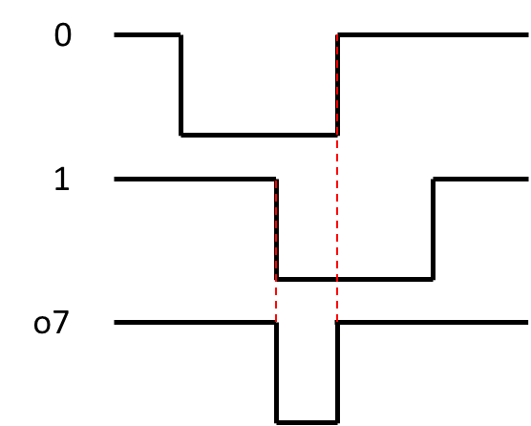
Then the o7 gate generates another gate, the “o4 gate.” Its width is given by “Ch Coinc Width” in the “Config Multi-Coincidence” window. The delayed fast triggers (Ch 0 given by o0) must be inside this gate. (The o7 gate is not affected by this; only the channel whose delayed fast trigger is being validated by this o4 gate is affected.)

External Trigger
The breakout module gives us a logic signal for a coincidence between the top and bottom PMTs of the LENDA bar, o7. Now we need a logic signal for the liquid scintillator. Send the liquid scintillator signal to a two-way splitter. One single will go to the Pixie module. The other will go to a constant fraction discriminator module. As a rule of thumb, set the CFD delay to 80% of the rise time of the signal. For the type of CFD module used here, the threshold can be tuned by looking at the CFD input and output and triggering on the output. Use a screwdriver to adjust the “T” screw. The walk can be corrected for similarly. Now look at the CFD output and Z/C from the module, and trigger on the output. Adjust the “Z” screw until both lines trigger evenly. The width can also be adjusted by turning the “W” screw. Here we use ~600 ns. Now check in the oscilloscope that there is enough overlap between the o7 gate and the CFD output.

Find Coincidences
Next, we will use a coincidence module to find coincidences between the o7 gate and CFD output. Connect o7 to “A” and the CFD output to “B.” Then “W” opens a gate whenever there is a coincidence between these two. The width of this gate can be adjusted with the “W” screw. Note: W is TTL, X is NIM, Y is something very short and almost never used.
The “W” output needs to be converted to LVTTL format with another module. Then this output signal will go to i4 of the breakout module. o3 shows this validation window.
Last, we need to enable global trigger validation in nscope. In the “CSRA” window, enable “GV” for all channels being used.
Check that the delayed fast trigger is in the o3 validation window. It should also still be in the o4 validation window. The width of the external trigger validation window can be adjusted in the “Timing Parameters” window in the “ExtTrigWidth” column.

